Omea Pro/Omea Reader 2.1 Changelog

Installation
- Omea Reader no more requires entering a license. Obvious blooper. First, it was useless for us (since we had no ability to process information obtained from license-related forms), besides it caused numerous mismatches in navigating users on our website.

Design
- Two related products – Pro and Reader are rebranded now. They have two different icons, more conforming to the corporate design style:

- They have different splash screens as well
- All icons have been reviewed. Shadows were removed from all icons, they became sharper and more distinctive, especially when small overlay icons are to be placed over them.

Outlook Plugin
- Attachments are categorized along with their container emails. Before we could not see attachment resources staying on some category in “Views and Categories” (“V&C” hereinafter) pane.
- Empty AddressBooks (ABs) are also shown in the address books list.
- Possibility to save attachments over readonly files.
- Possibility to send attachments without preliminary saving to disk.
- New distinctive icon for mails with attached resources:
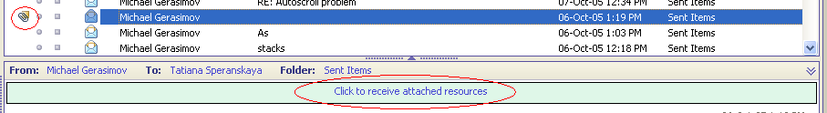

- Outlook Meetings are now separate resources, definitely separated from ordinary mails. Omea can now open them in Outlook via Enter key or dbl-click, visually it is designated with a separate icon:
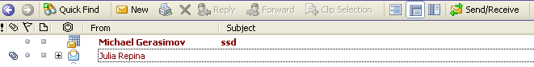

- Email attached to other emails are now can be directly opened.
- Several options which automate assigning of categories to mails:
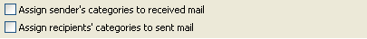

- Save email message(s) as text file
- Expiration rules for Outlook folders:
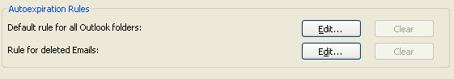

- Fixed a bug with dragging a whole conversation containing attachments to some Outlook folder.
- NUMEROUS other bug fixes

NNTP Plugin
- Options: “Mark all read on exit” and “Mark all read on Leave” for a newsgroup:

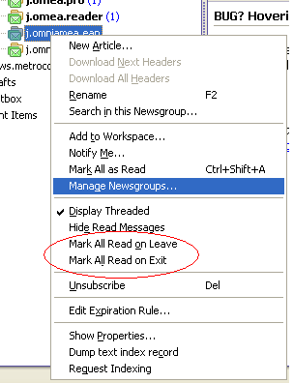

- More strict logic is implemented for controlling the resources deletion. Given the News articles as the example:
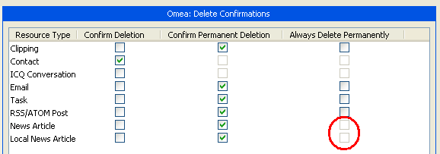

What this generally means is that there will be no possibility fo a user to accidentally delete articles permanently – either with the help of a rule or via keyboard.
- “Watch Conversation” – possibility to create a special formatting for a [sub]thread, specifying its head:
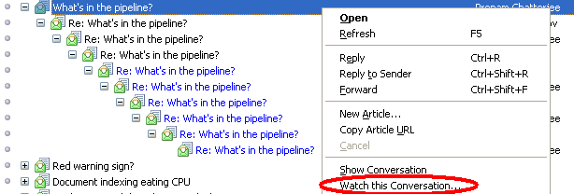

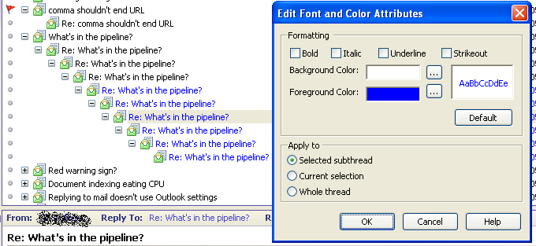

- “Stop this thread” – possibility to delete all subsequent news articles which belong to the specified [sub]thread:
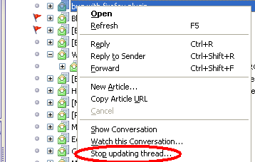

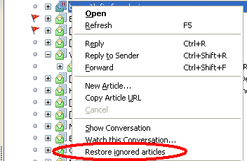

RSS Plugin
- Create Feed Folder on the top level not only in the Subscription Manager (nightmare!!!)
- Completely redesigned export of feed subscriptions.
- Option “Auto update feed comments” is moved from popup menu to a “Properties” dialog for a feed.
- “Move a feed to Feed Folder” menu item for “keyboarders”

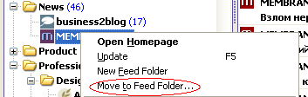

- Option to show feed’s FavIcon as the primary icon of the feed post, both in resource list and in newspaper:
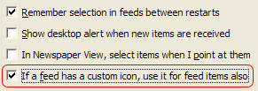

Example:
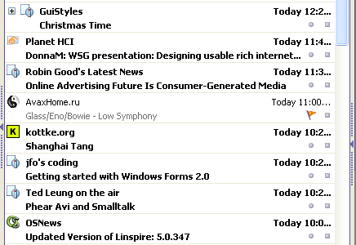

- Unified progress display for feeds downloading in the status bar
- In Newspaper view we added an icon for an Enclosure status.
- Ability to pause the updating of the RSS Feed for an arbitrary period of time:

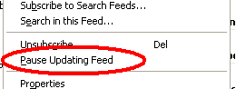

Feed title becomes a little bit “grayed” and a “PAUSE” icon indicates its status:
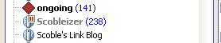

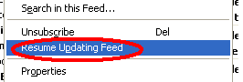

- In 2.0 there was only one column for showing the origin of the feed – “Author, Weblog”. Now ordinary column “From” is additionally added.

RSS Search Engines
- Added the following search engines:
  - MSN Search
  - BlogPulse
  - Google Blog Search
- Subscribe to any number of search feeds, not only one by one:
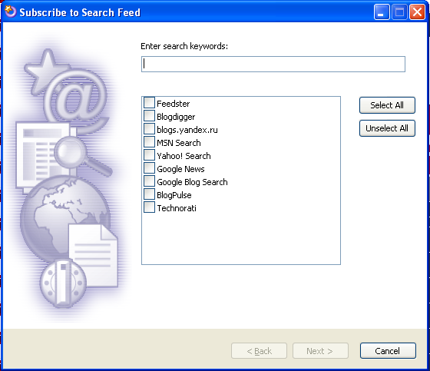

Tasks
- Possibility to create Sub/Super task relationship. This is done via D’n’D in the ToDo pane;
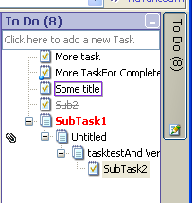
- Added some formatting for finished and overdue taks
- Support for “Deferred” status of the task
- “Task Importance” column is now pictorial (instead of textual)
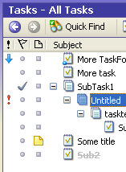

Clicking on the importance icon changes the task statusin circle.
- “Task Status” column is now pictorial (instead of textual):
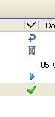
That is (following the order in the column): deferred, waiting, not started, in progress, complete.
- Task Edit form was redesigned to structurize the task-related information.
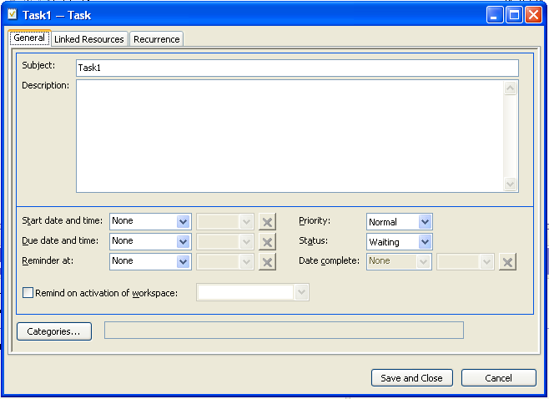

  - Single form was split into several tabs
  - Date controls were redesigned so that they are usable both from keyboard, mouse and stick (for tablets).
  - Added logic between different controls.

IMs
- Save into file and send by mail multiselected IM conversations.

Contacts Plugin
- Correspondence is shown for ALL selected contacts in the Correspondents pane (previously only for the first one).

Filter Condition/Views/Rules
Features listed here are given alltogether instead of being distributed over the separate topics (by plugin).
- Separate conditions: “From or To contact”, “From contact” and “To contact” (in addition to the existing one “From, To or CC to contact”)
- RSS condition: “Post is in the search feed”
- RSS condition: “Post is a comment”
- RSS condition: “Post is a comment from blog’s author”. This for example allows us to highlight the comments from the author:
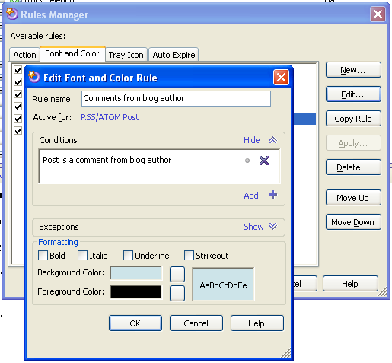

- News condition: “Message is a reply in a flagged thread”.
- Two news conditions: “Message has a reply” and “Message is a reply”. As an example of usage I can show mine – “highlight all news articles which nobody has answered to yet”:
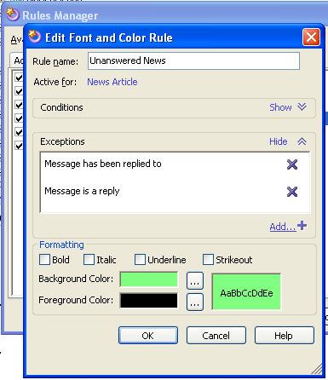

- View “Next Week” for Tasks
- We have a VERY special condition now: “Contact has correspondence”. Condition is true for those contacts which have at least one related email, news article or feed post, including those which are deleted and may be found in the “Deleted Resources” view. Follow up for this condition may be found in “ToDo” section. This condition in the following rule
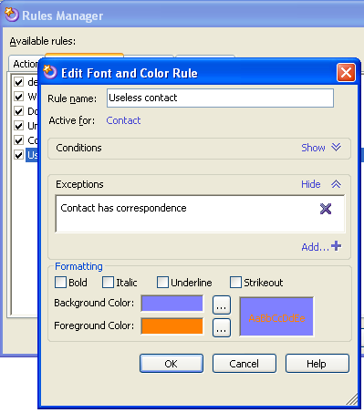

highlighted me all garbage contacts. With the help of this condition I created a view and deleted approx a half of all contact resources – I used an action “Clean unused contact” which can be applied to the view. I suppose it is what most of us wanted for months ☺.
- Expiration rules now may be configured so that they do not touch categorized resources as well:
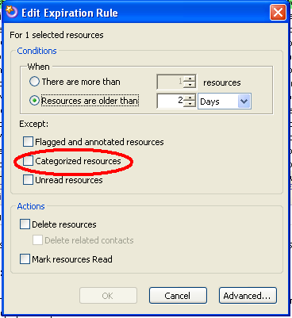

GUI/Usability Issues
- Ability to sort feeds, newsgroups and tasks (in the ToDo pane) via drag’n’drop.
- Toggle Read/Unread state by clicking on the resource button.
- Ability to delete annotations for multiple resources simultaneously.
- Select/Unselect buttons in many places – Feed subscription dialog, Outlook Folders, Outlook Address books option pages
- Corrected buttons behavior in Feed subscription dialog
- Most TextBox controls were changed so that Ctrl-A and Ctrl-BS work properly
- Tab key from “V&C” pane moved nowhere, now – to the resource browser list.
- Option for regulating the amount of time the notification window stays on top
- Possibility to customize the color of notification window:
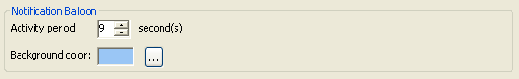
- “Delete” button on the notification window
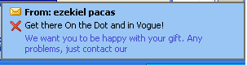

- Support “Display Threaded” and “Hide Read Messages” in categories (“V&C” pane)
- Ability change the icon for the category so that it appears both in V&C pane and in the resource browser list:
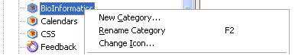

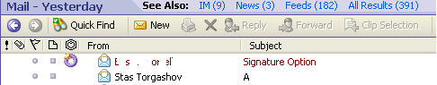

- Toolbar icons for turning on/off groupping and for choosing the location of preview panel – bottom or right:
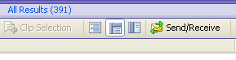

- Alt-F1 key for switching the visibility of left sidebar on/off
- Problem of views duplication when dragging them in the Views Manager is fixed
- Possibility to change greeting string for emails and news (not separately yet, sorry):

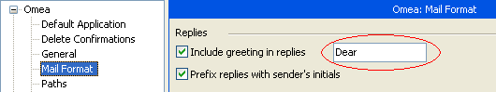

- Hurray – we can change fonts for major resource types:
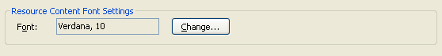

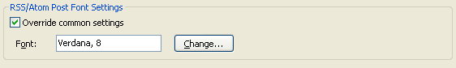

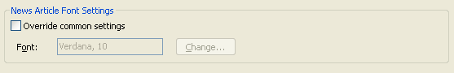

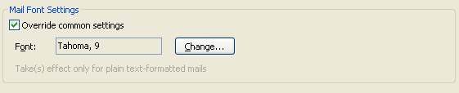

- It is now possible to reorder Workspaces:
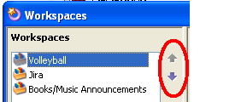

- “Show Clipping” and “Annotate Resource” dialogs are redesigned to resemble each other in layout. Additionally we tried to make it possible to create a new category from any place where it might be necessary.

FireFox Plugin
- It works again!!! (with FF 1.5)

Text Index
- New menu item (in Actions menu): Pause/Resume text indexing. This allows user to have more explicit control over the Omea (and the computer at whole) performance.

Optimizations
- Reduced memory consumption
- Reduced hard disk reading/writing
- Improved multithreading and UI responsiveness
- Reduced startup and closing time
- Optimized for running on multiprocessor or hyper-threaded computers
- Feed updating consumes less system resources
- Faster import of ICQ history
- Self-organizing database (in idle mode) for faster queries

Omea-Wide Changes
- Opening a link in a new Web browser window is now performed asynchronously, so that Omea won’t hang if the Web browser or some other application is not responding at the moment.
- Drag’n’Drop reordering of resource trees: it’s now possible to change the order of items in the lists and trees with the mouse, as well as reset the user order back to lexicographical sorting.
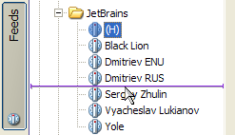
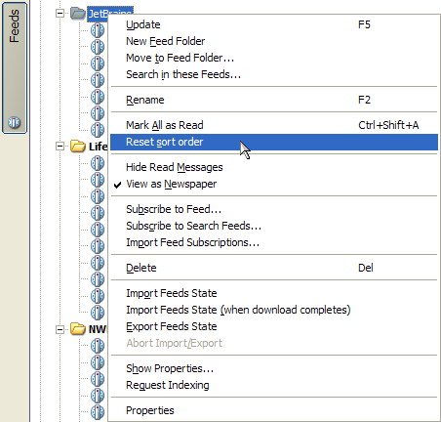

Open Issues
Features and bug fixes covered in this section are to be finished before 2.1 release:
- Task recurrence pattern. Currently most of the controls are in-place already, we need to complete the processing part.
- Show view only in the predefined workspace(s). Currently user can specify that in the “Edit View” dialog directly, but there is some logic behind to put it into “Manage Workspaces” dialog:
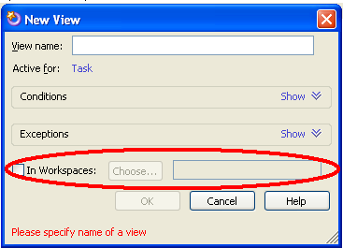
- Configure set of prefixes (like “RE” or “FW”) to be ignored when sorting by subject.
- Reordering in the V&C pane
- Crashes in text index. We still have problems in reproducing this.
- Incorrect parsing of URLs in emails and news articles.
- Merging contacts
- Tasks duplication when synchronizing with Outlook
- Exceptions in Replies to news articles. Most of these exceptions are related to .Net 2.0 and the lack of testing under it.
- Skipping RSS posts with equal description string
- News articles encoding issues
- Performance, performance, performance…
- Bug fixes. Please do not warry if you did not find your most upleasant bug in the list above. There is always a chance that we will fix it.

